Recommendation:

Increase image capture from 8-bit low-resolution to 12-bit resolution to improve image detail.

Deliverable:

Develop the python code to handle 12-bit resolution images and redevelop/update the GUI.

Recommendation:

Develop a more portable and reliable enclosure, this will be an enclosure that houses components securely and prevents dust and water ingress.

Deliverable:

Design and construction of an improved enclosure.

Recommendation:

Implement power management to optimise power consumption.

Deliverable:

Modification to the electrical circuitry to optimise the power.

Power Source

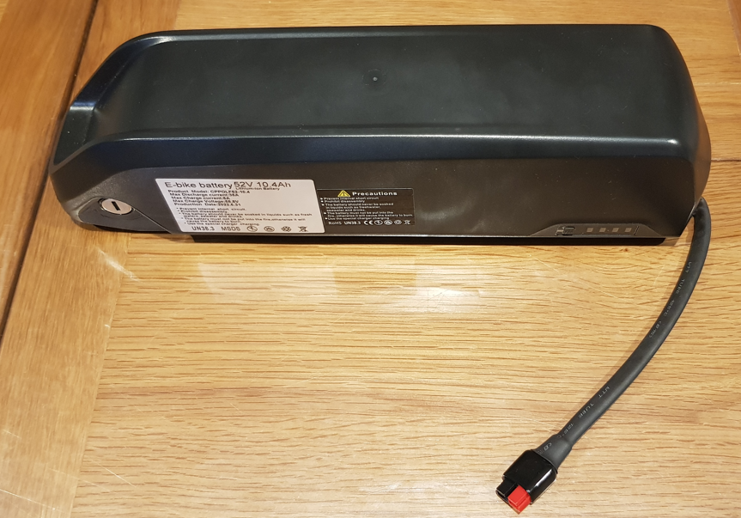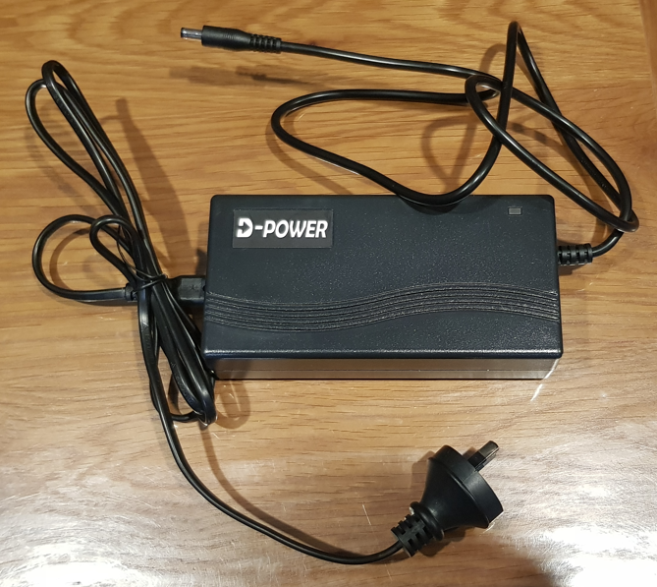

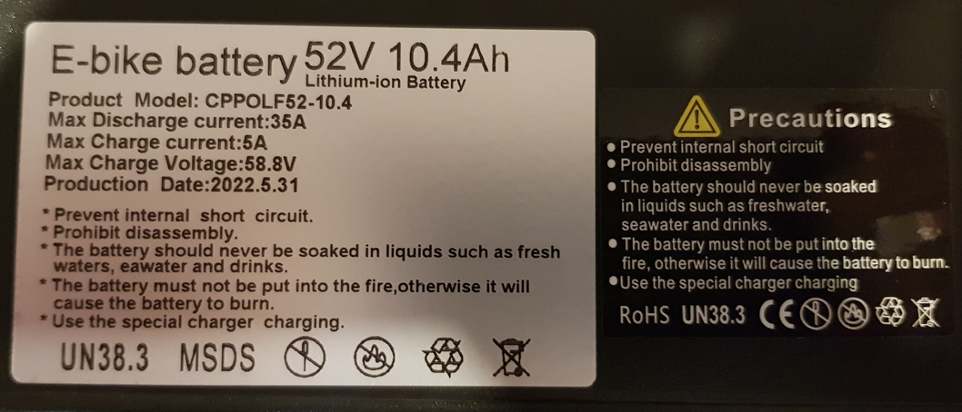

Connectors are Anderson Powerpoles PP14/30/45 Series (Current Ratings) (see ebikes.ca/learn/connectors.html).

Jaycar Cat No. PT4405 30A Anderson Power pole Connector Set $5.50

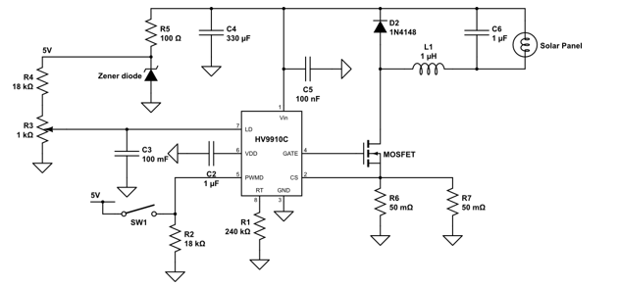



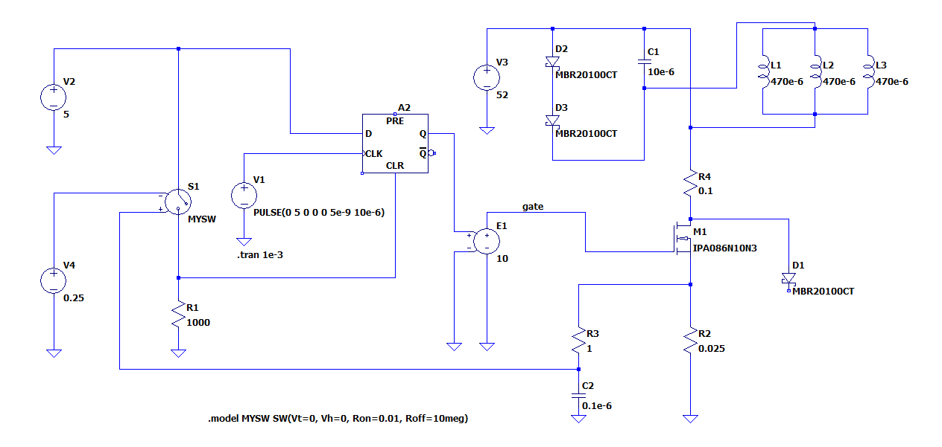

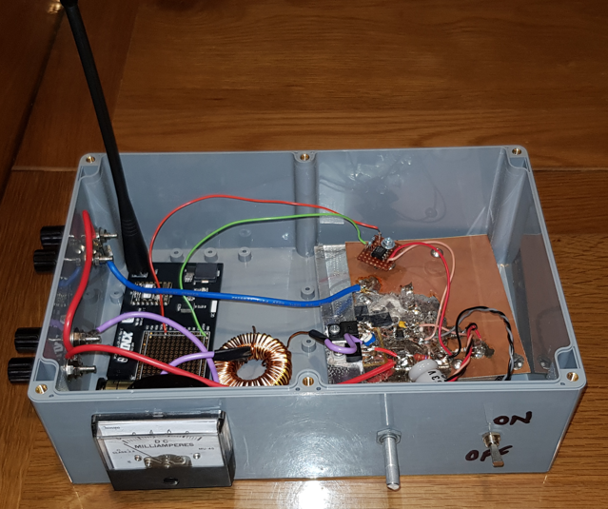

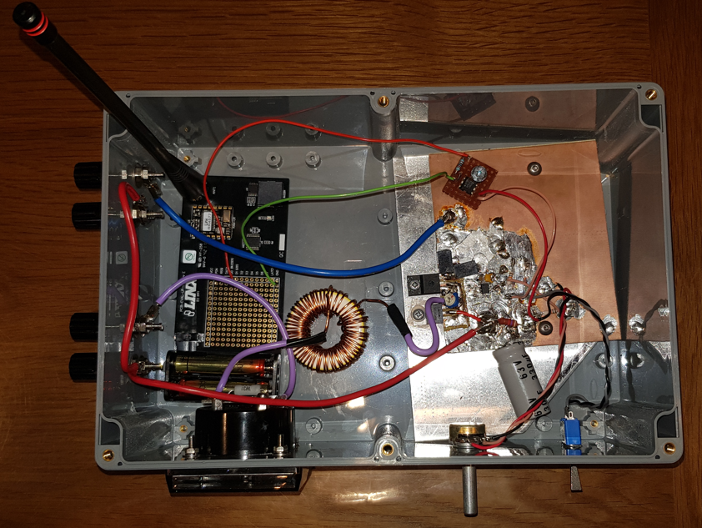

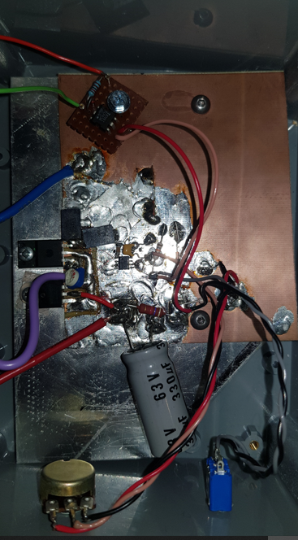

Recommendation:

Create a PCB board to for circuitry currently seated on a prototyping board.

Deliverable:

Construction of the PCB for the electrical circuit to replace the prototyping board.

Recommendation:

Increase the current rating above 10 A to allow the device to scale to work with larger PV modules.

Deliverable:

Recalculation of the component values of the electric circuit to handle loads above 10 A



